Write Up

Process/Planning: For this specific assignment I first started by thinking of how I wanted to be seen online and what it is I did that could be most presented online. Which led me to basing the website around coding, with hints of travelling and food. Then I basically went through various websites trying to decide what look would best fit my website. After I was done looking and had a pretty decent idea of what I wanted the website to look alike (even though it was changed multiple times after this but still stuck to the rough idea) I drew up the basic look of the site using wireframes. I then went to photoshop to create the visual identity of the website (which was revised over and over to basically imitate the final product) taken into consideration accessibility and usability for users of the website. When this was done, I then started coding the website, with index as my first page as expected. I used index to build up on the remaining pages, with about coming in second, contacts as third and works as the last page because I felt it would be the most tasking. My goal was to create a website that was easily navigable and accessible with content targeted to a specific audience. My target statement being “I am a food and travelling enthusiast who offers superb technical support to tech companies who are in need of front-end services.”

Consideration of accessibility and usability requirements: For this I made sure the colors I picked for the website were user friendly and could be perceived well by most. I made sure by using the accessibility tools available on the course website. Made sure the global navigation menu items were within the recommended numbers which is 3-7. I provided quick links that allowed for associative navigation and easy navigation. Alt tags were correctly identified in order to allow users know content of images if the specific images were not able to load properly. Avoided limiting content to file types such as doc, pdf and instead made them more accessible. The video contains mostly visuals and text apart from the last few seconds that a club is mentioned but then a link is shown so captions were not a top priority. Made efforts to having text still readable if resized to 200%, having the website navigable just with keyboard and still operational without JavaScript. Made texts as simple as possible so they could be more readable.

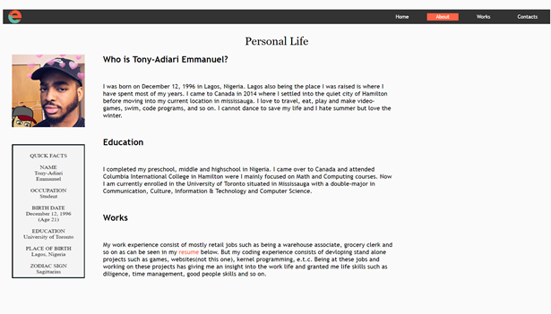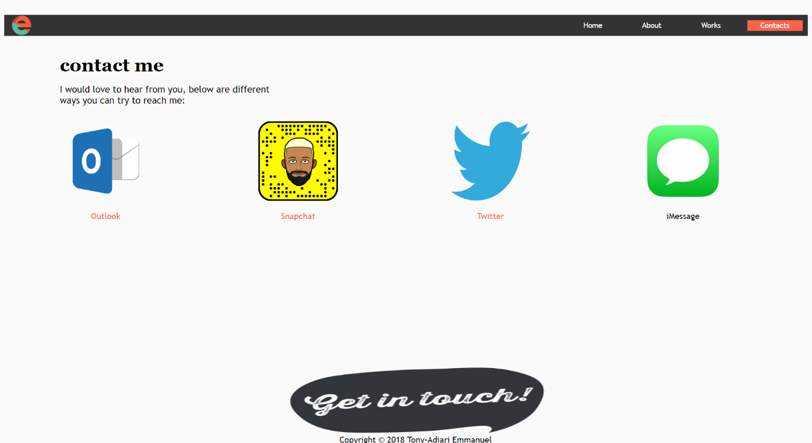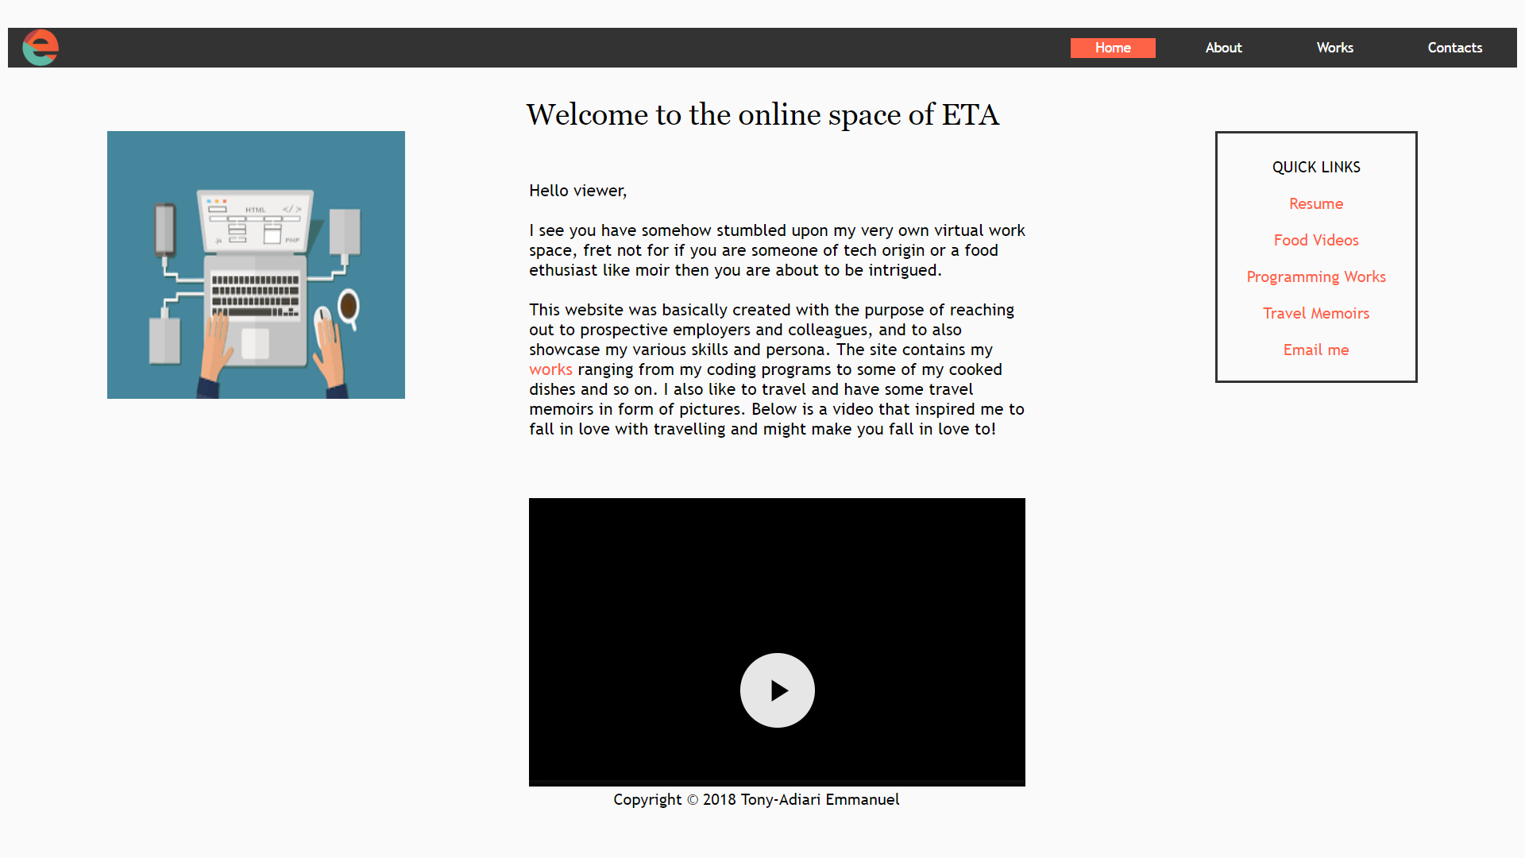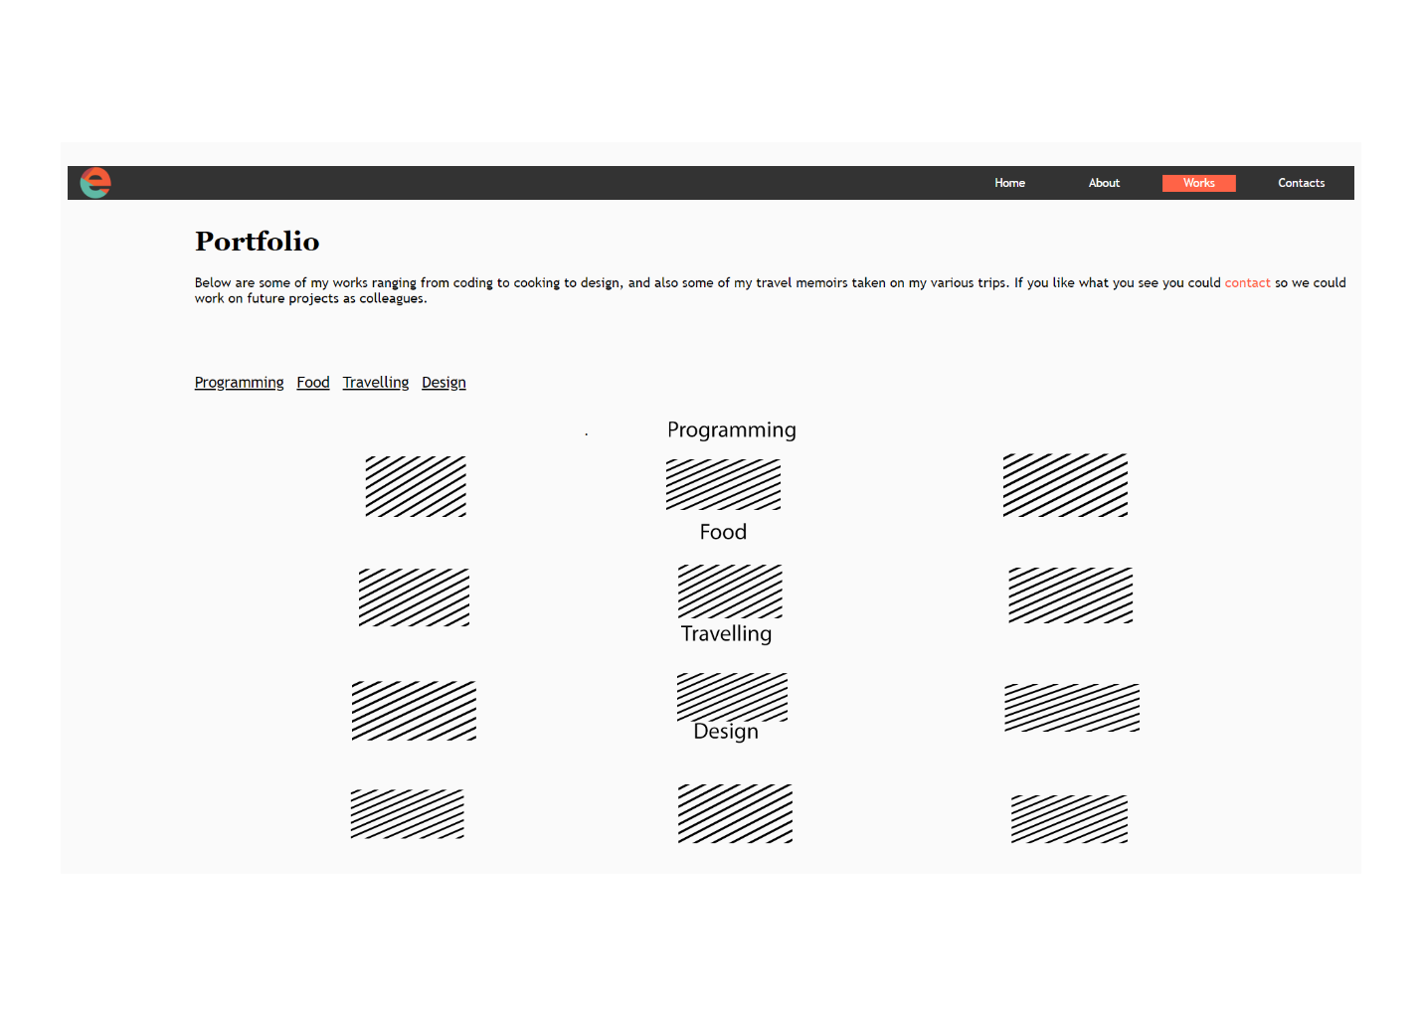

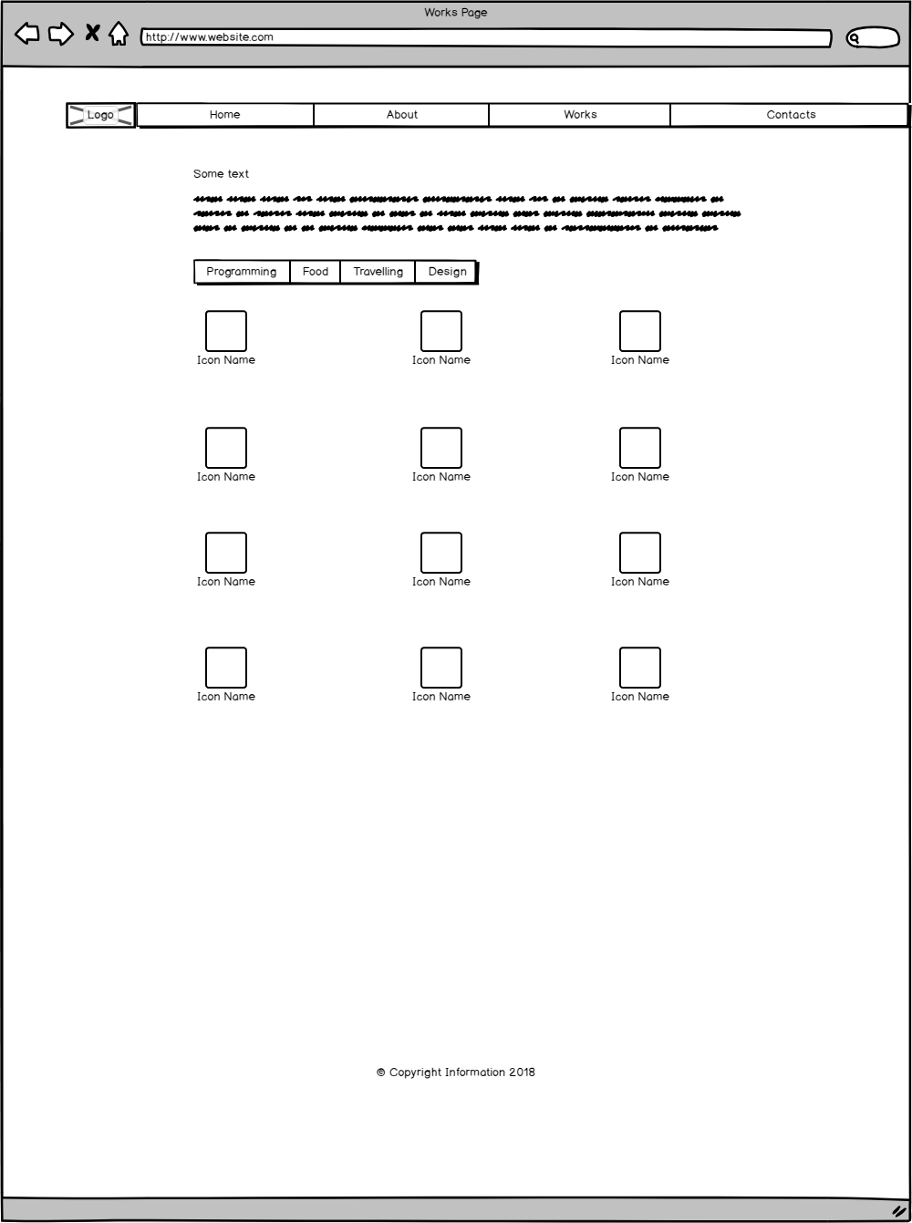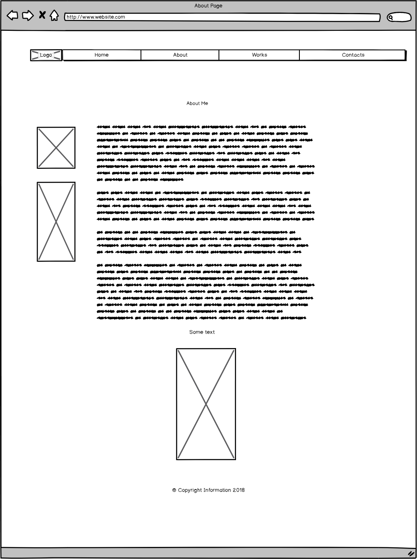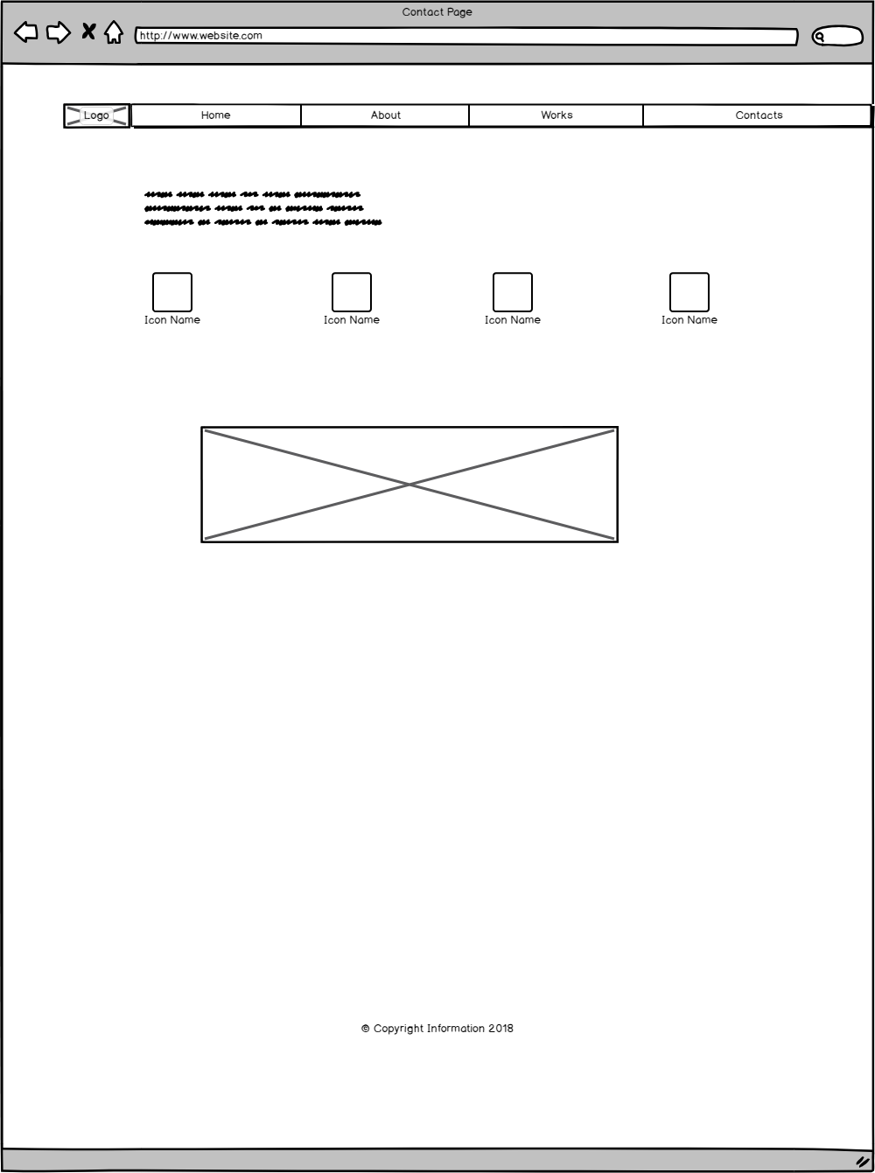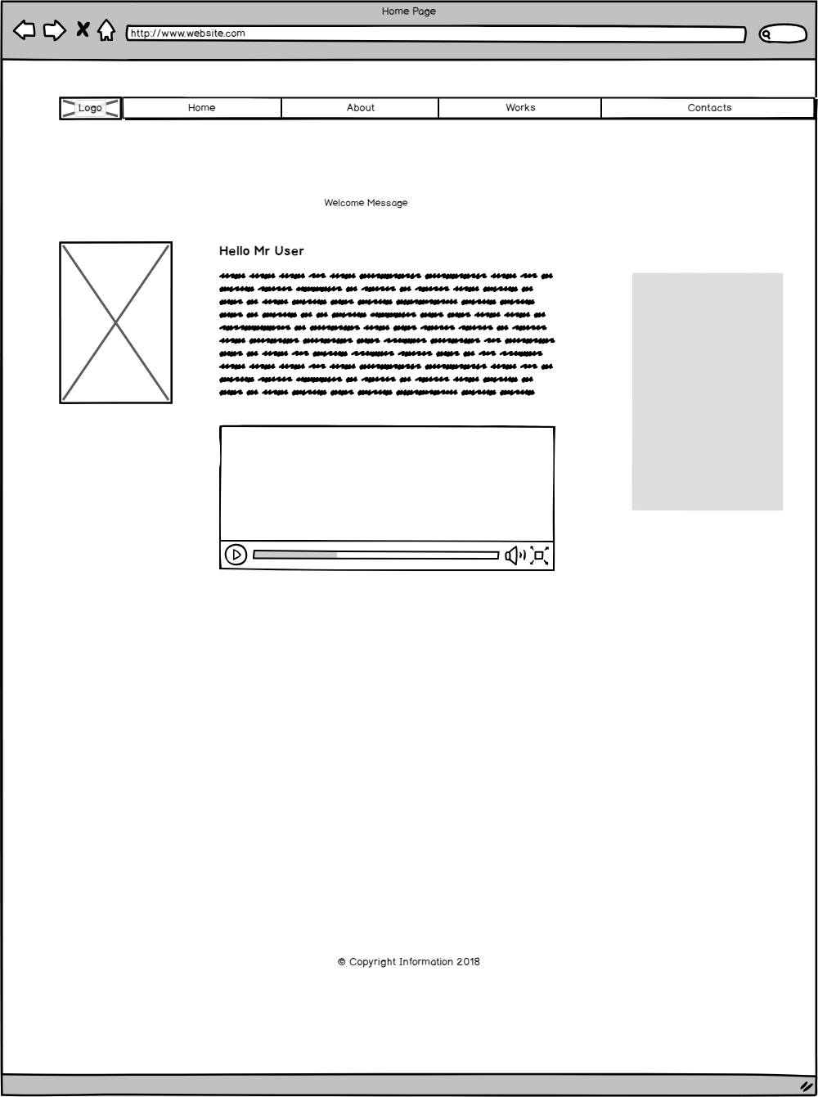

References

<https://simpleprogrammer.com/learn-programming-language/> – coding image

<https://pngimage.net/get-in-touch-png/> – contact image

<https://icons.webtoolhub.com/icon-n89079-detail.aspx> - outlook image

<https://en.wikipedia.org/wiki/Kernel_(operating_system)> – kernel image

<https://www.reddit.com/r/westworld/comments/7rb2vv/hurr_hurr_doesnt_look_like_anything_to_me/> - maze image

<https://www.macworld.com/article/3083907/data-center-cloud/when-sharing-an-apple-id-creates-imessage-and-text-message-confusion.html> - iMessage image

<https://exodusescaperoom.com/the-benefits-of-puzzles> - puzzle image

<http://www.stickpng.com/img/icons-logos-emojis/tech-companies/twitter-logo> - twitter image

<https://www.energysys.com/energysys_avatar-logo-transparent-bg/> - eta image